**OPEN-SOURCE TECHNOLOGY PROJECT REPORT**

**INT 301**

Submitted by

Kotharu Venkata Vikram Aditya Registration Number: 11901842

Roll no: 36.

Under the Guidance of

**Dr. Manjot Kaur**



**1) INTRODUCTION**

**1.1) Objective of the Project**

To Generate Payload and exploit windows machine using Metasploit framework.

**1.2) Description of the Project**

In this Project we have to send a payload using Metasploit framework ( kali Linux) which can control actions on victim machine. The Metasploit Framework is a powerful penetration testing tool that allows security professionals to identify and exploit vulnerabilities in a target system. The Payload will be a “.exe” file which can Shut down, Restart, delete files, Open camera, Record Videos, Screen Share, etc.

**1.3) Scope of the Project**

Gaining a basic understanding of the Metasploit framework, including its structure and different modules. choosing a Windows system to exploit as a target. developing a payload that works with the operating system and architecture of the target machine using the payload generator module of Metasploit. identifying potential payload weaknesses that can be used to compromise the target system. setting up Metasploit so the payload can be launched, and the target computer can be exploited. gaining access to the target machine and carrying out different post-exploitation operations, such as privilege escalation and data exfiltration.

**2) SYSTEM DESCRIPTION**

**2.1) Target System Description**

In this project, we have decided to target windows 10 machines and send payloads to it using Kali Linux

**3) Analysis Report**

**3.1) System Snapshots and full analysis report**

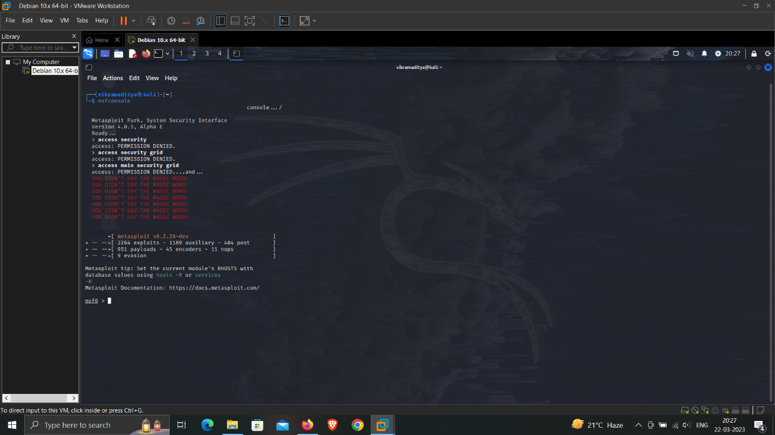

Go to terminal and type msfconsole to get access of Metasploit framework access.

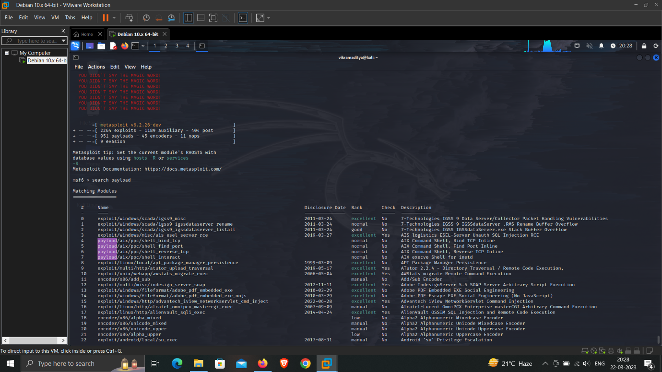

For exploiting the windows, we need a payload, we can search payload in msfconsole using “search payload” command.

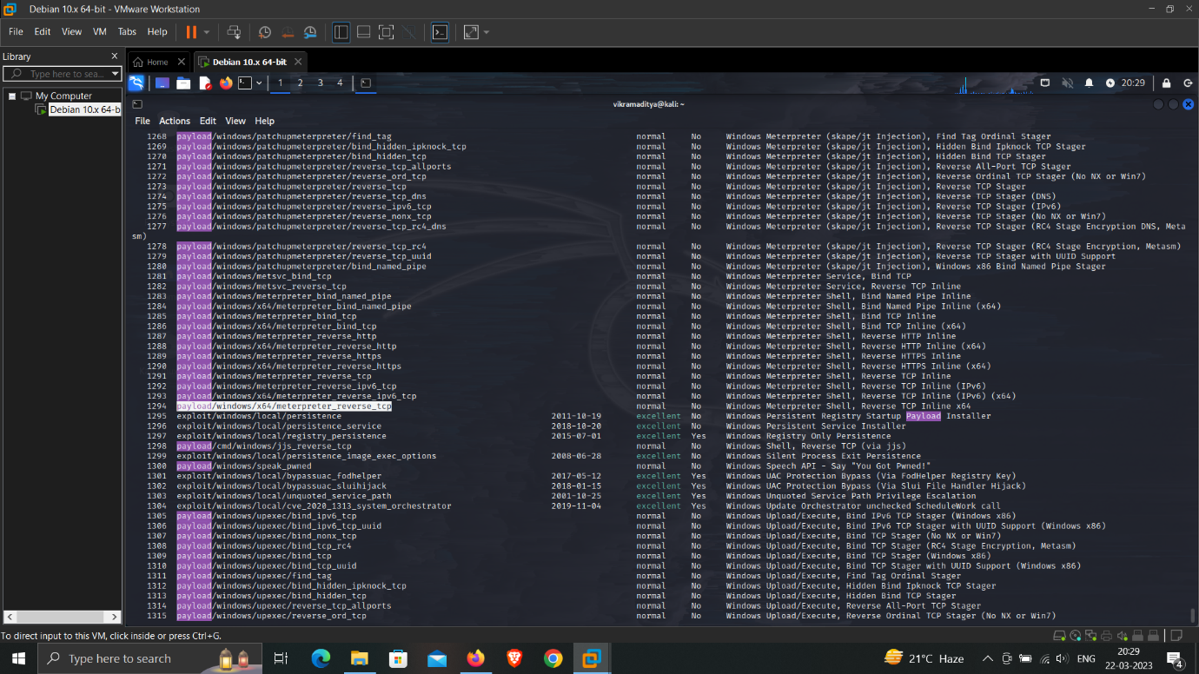

For exploiting windows, we are going to use “meterpreter_reverse_tcp payload” which is most popular for exploiting windows machines.

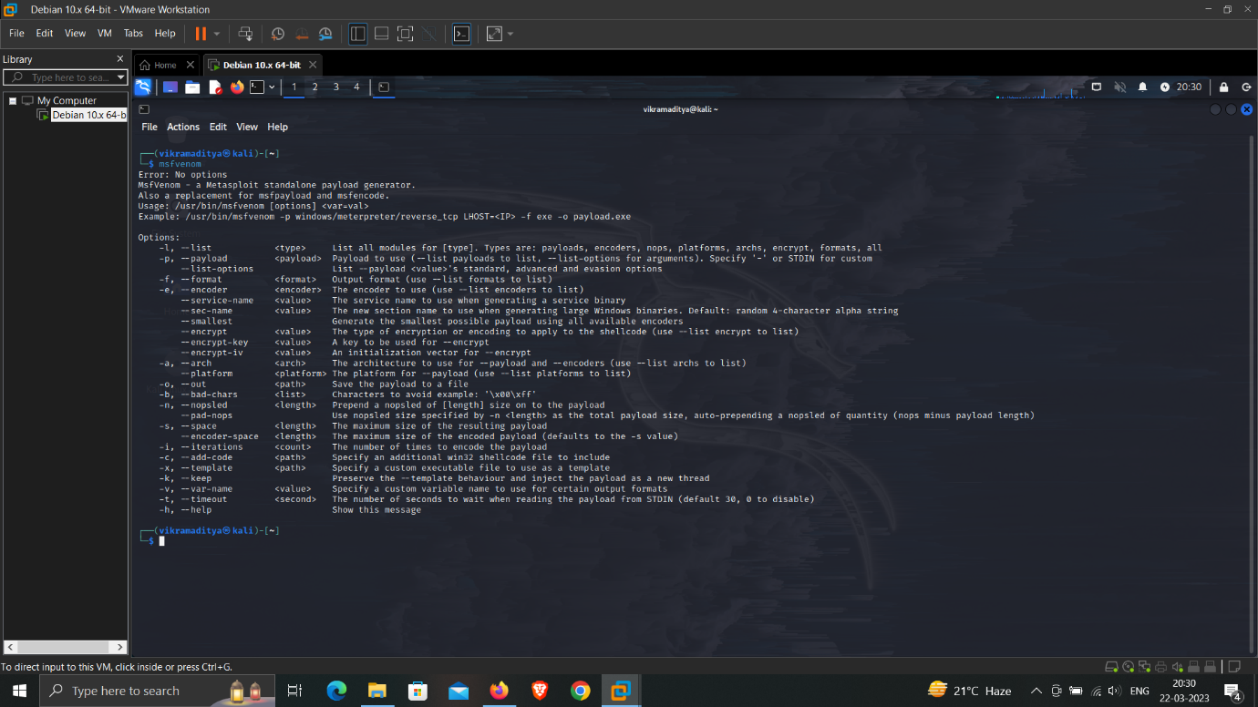

Msfvemon is to create payload in metasploit.

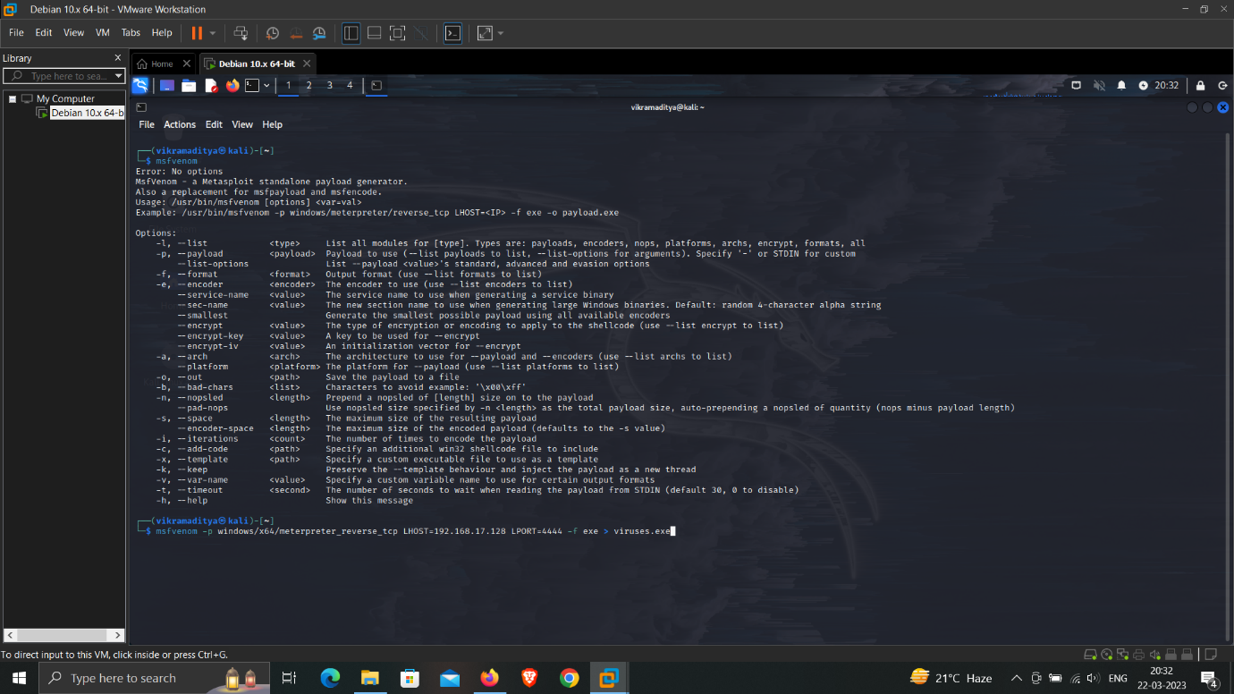

As we already chosen our payload , we will create payload using msfvenom is which we will be giving LHOST as ip address of the victim machine and LPORT as 4444, which is a standard port used by Metasploit, and after that we will be giving the file extension type and file name.

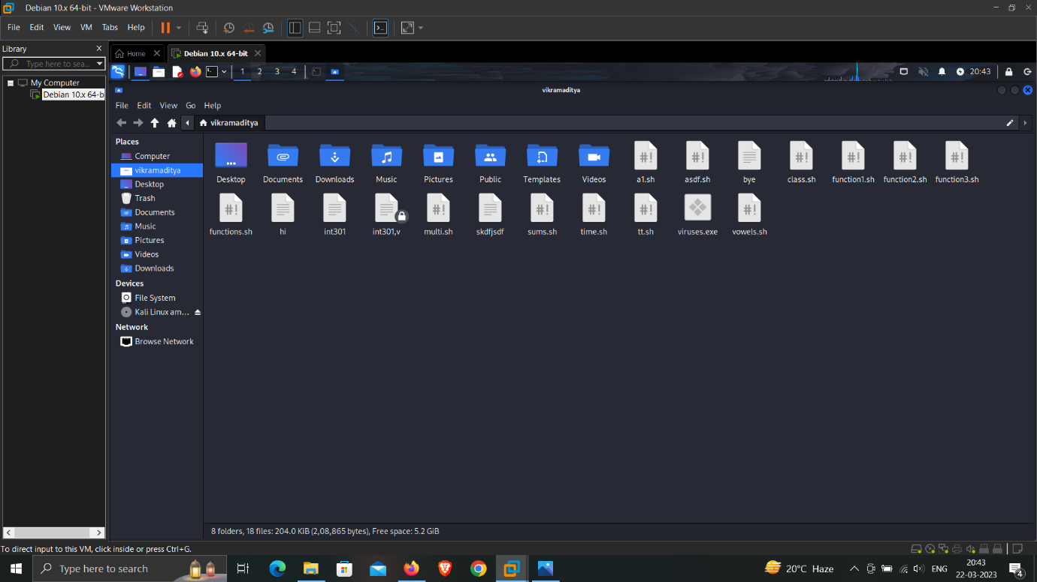

As we can see the viruses.exe file has been created



To exploit windows, we can send this file to windows via pen drive. And we have to turn off the windows defender.

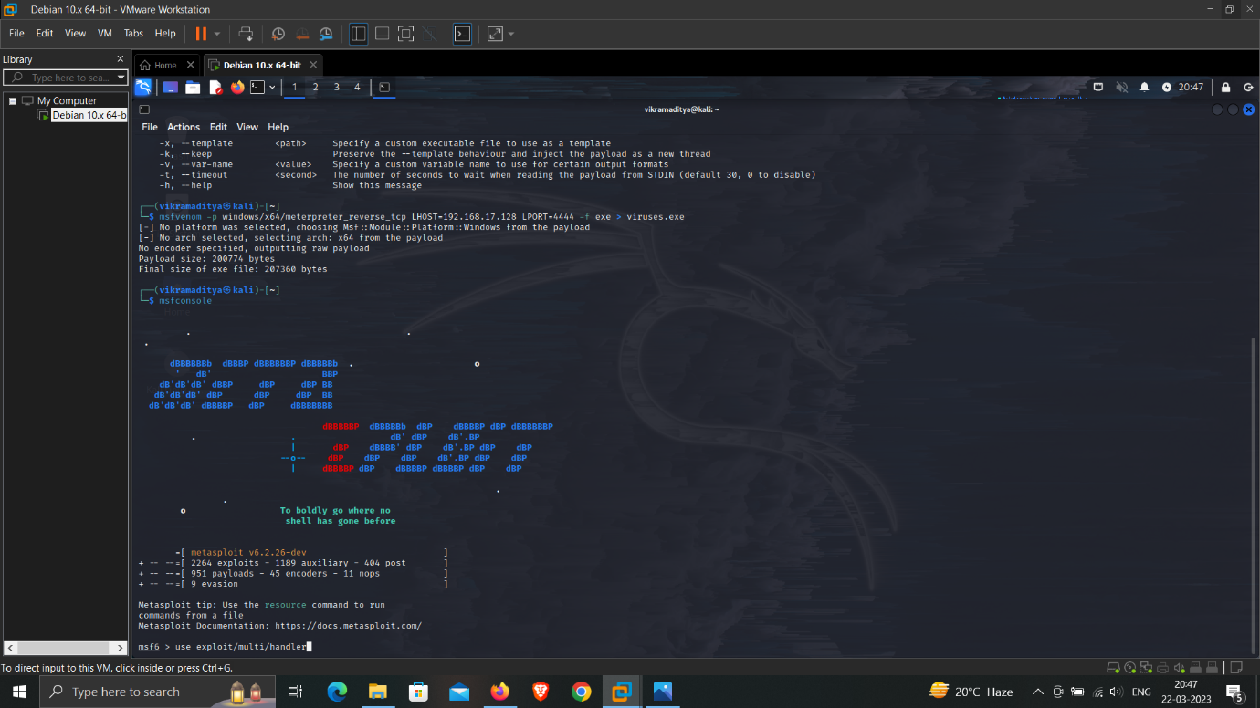

After the creation of payload, we have to open msfconsole and type exploit/multi/handler. Multi handler is the one and only exploits which can handle all the available payloads in Metasploit. It can deal with all the payloads no matter what the purpose of the payload is and how the connection is.

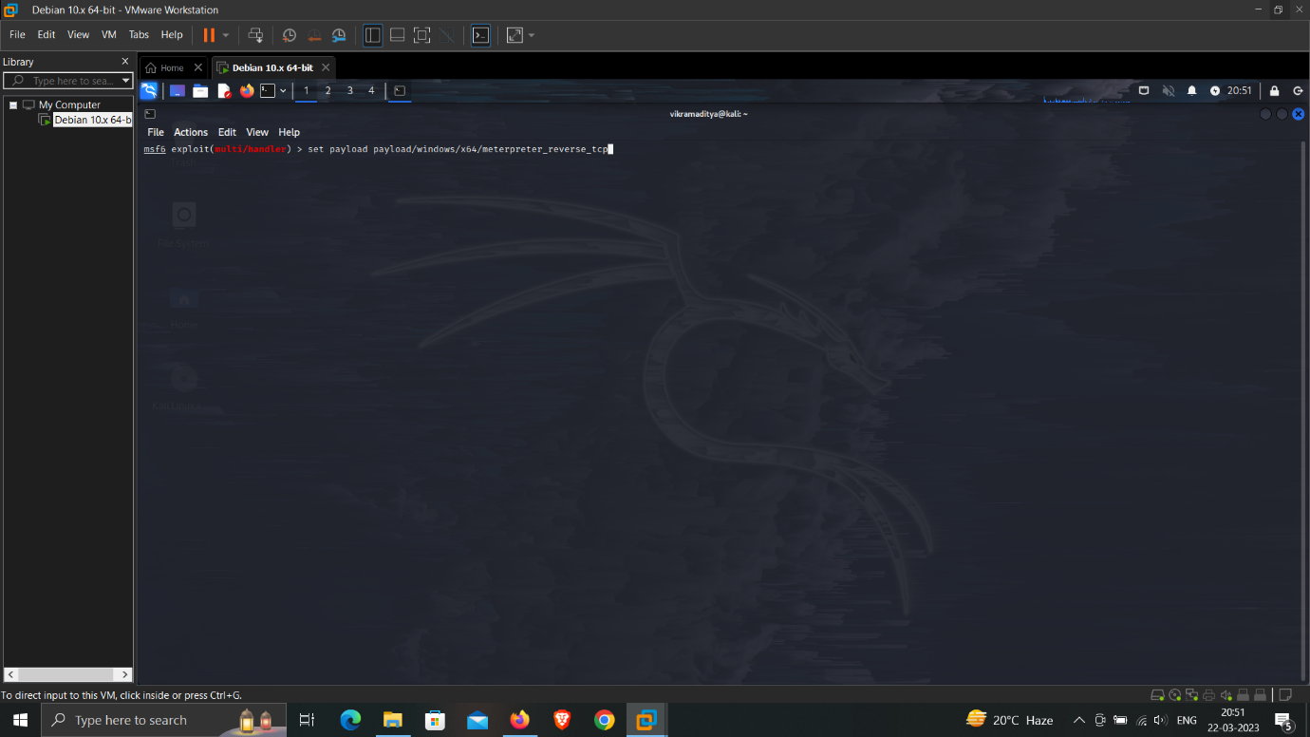

In this step we will be setting payload.

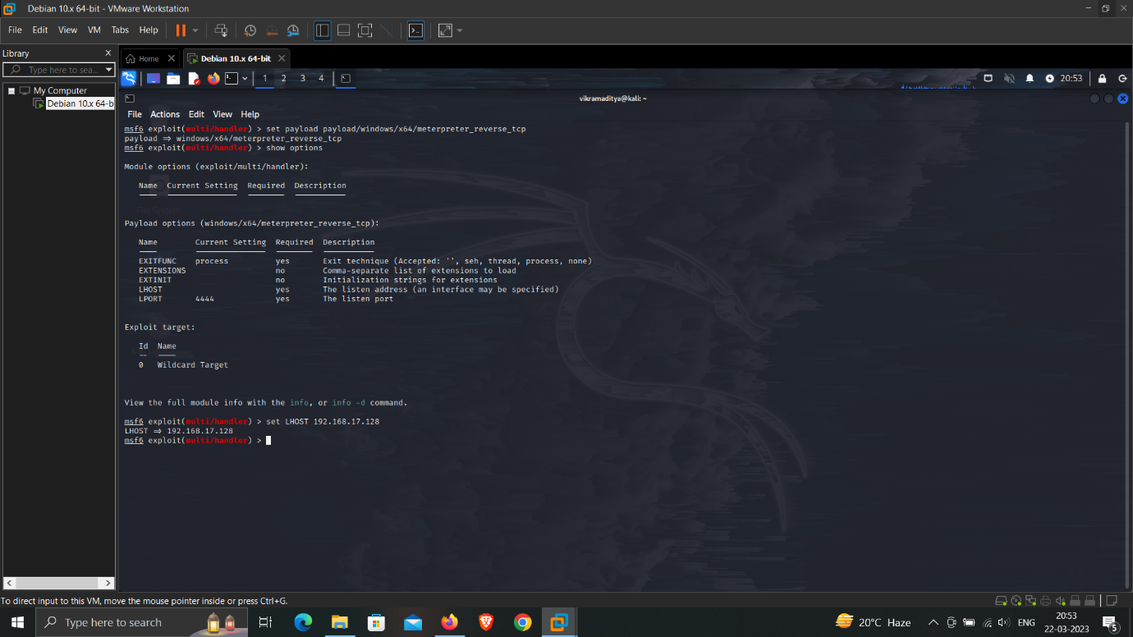

After the payload is set, we have set the LHOST value as ip address of the victim machine.

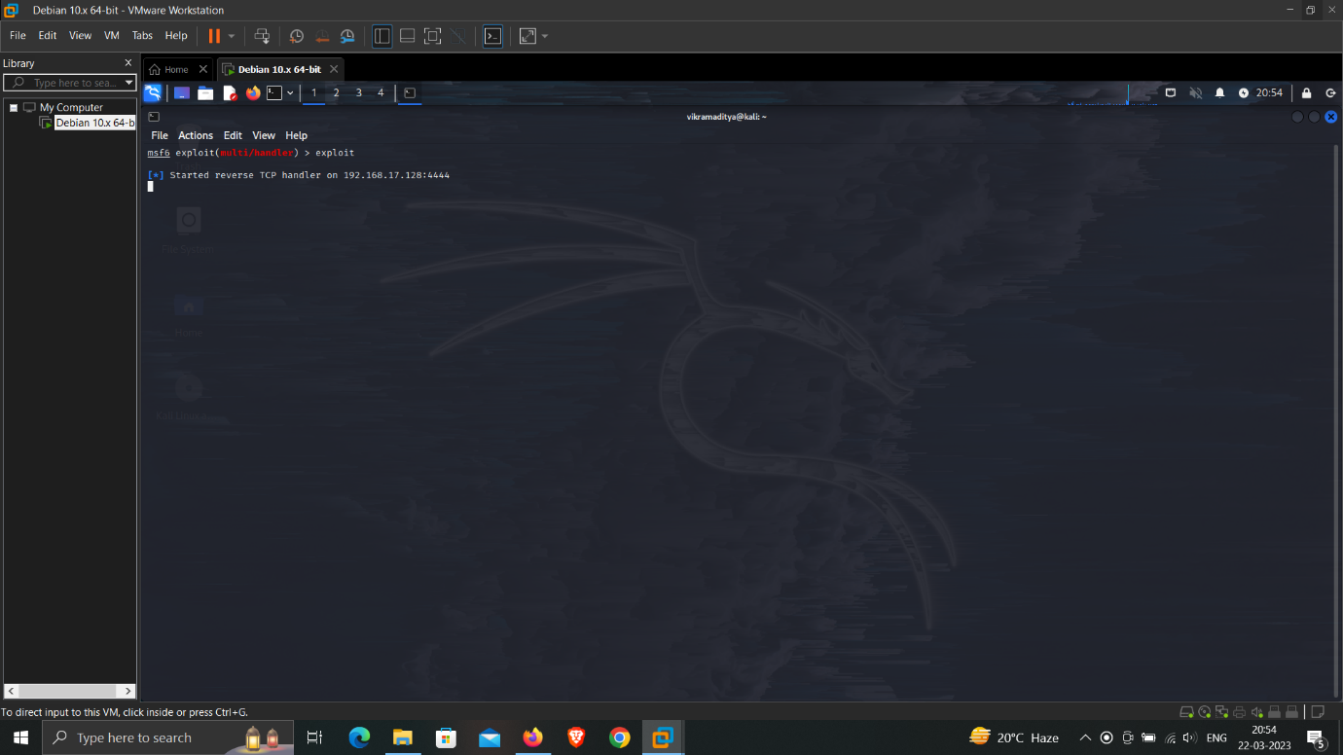

After setting the ip address in options, we have to type exploit, so that payload starts working on victim machine.

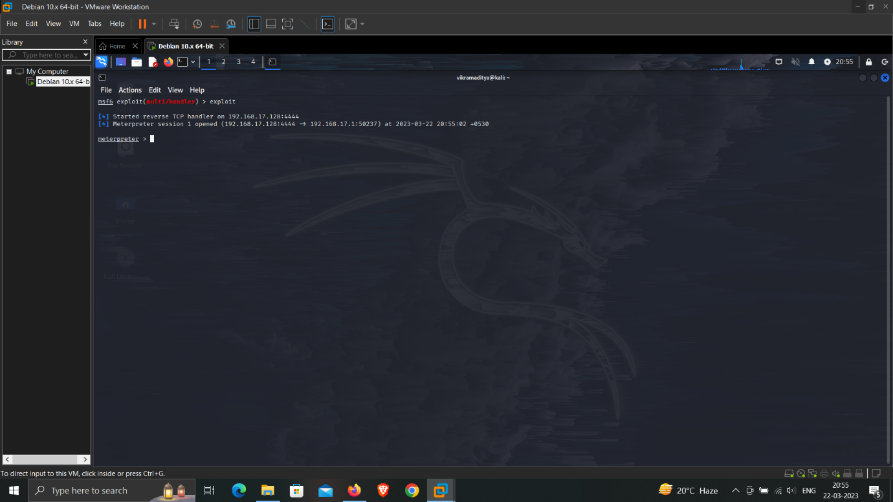

If user clicks on the .exe file that we have sended , then a session will be created.

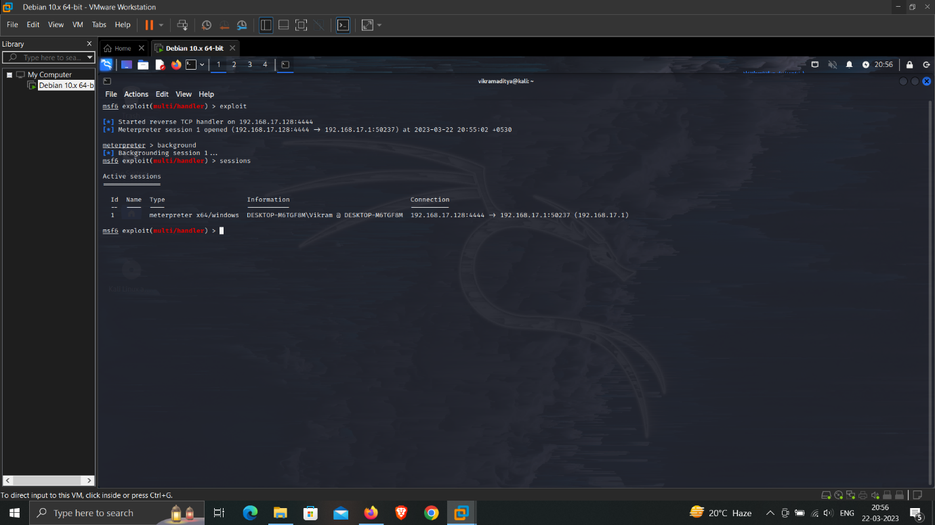

As we can see the victim’s computer information and session id is visible.

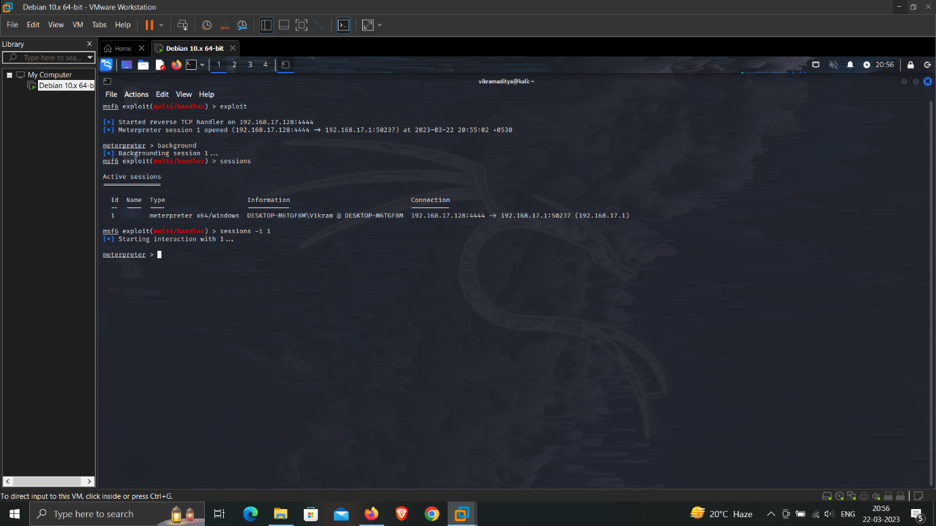

To start exploiting the victim’s machine we have to enter session -i 1(session id)

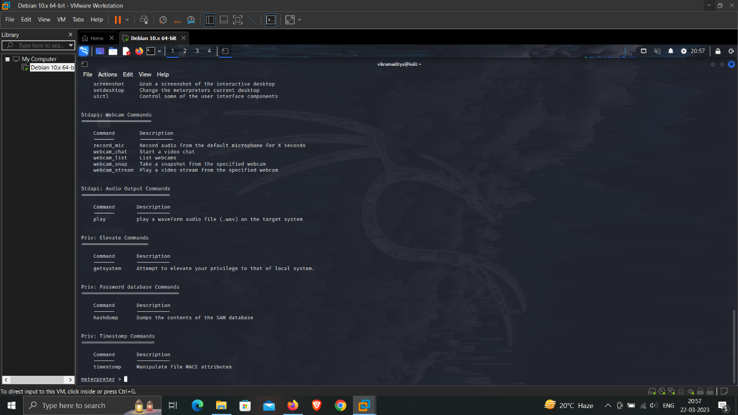

After entering the session id, to see available exploiting options , type “help” in the command line, as we can see the list of commands with unique functions to exploit.

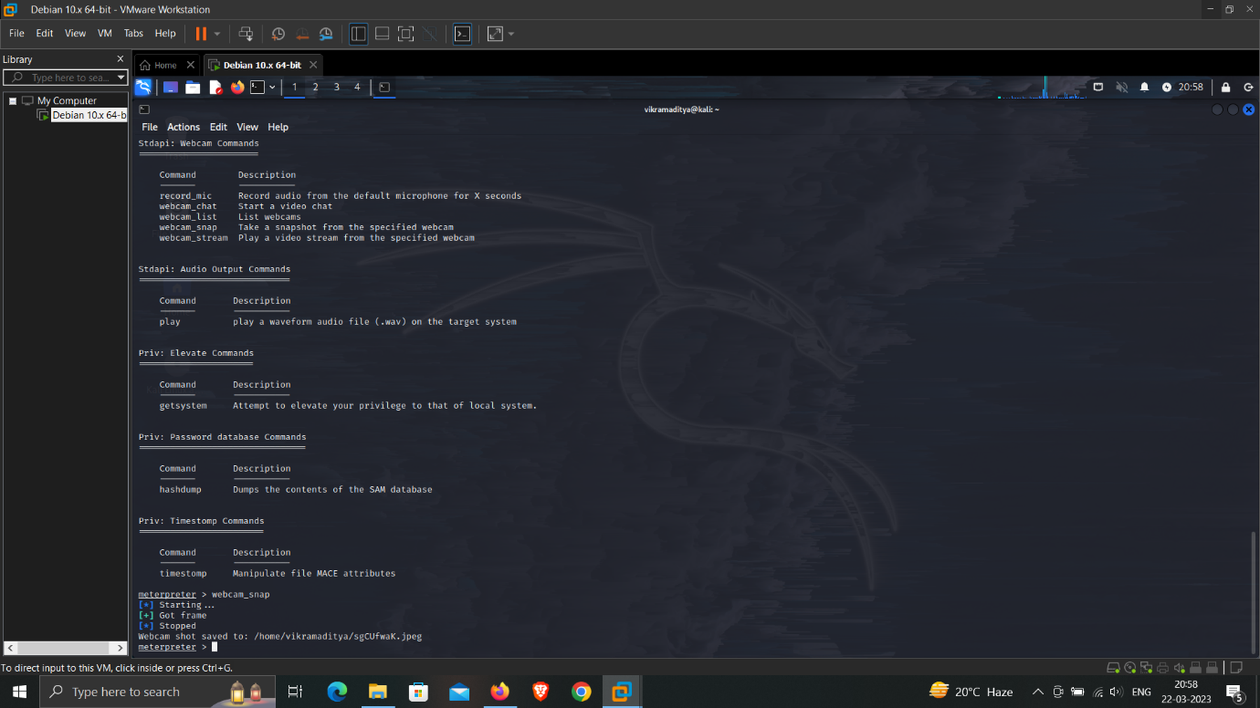

For example we are going to take “webcam_snap” command which will take a quick picture of the victims face. And will be stored in our system.

In this way we can exploit a windows machine, using Metasploit framework.

**4) References / Bibliography**

1)<https://www.metasploit.com/>

2) <https://www.geeksforgeeks.org/>

3) <https://www.kali.org/tools/metasploit-framework/>

4) <https://www.youtube.com/@JosephDelgadillo>